**AWS Lab 4**

**Leo Reyes**

**Purpose**

The purpose of this lab was explore creating VPCs by using the VPC wizard in AWS. It allowed me to explore a different way to assign private a public subnets to a VPC as well as launch an Elastic Compute Cloud (Amazon EC2) and use a NAT instance in a VPC. Additionally, it allowed me to explore more of how to create elastic IPs and how to allocate one to be used in the VPC.

**Process**

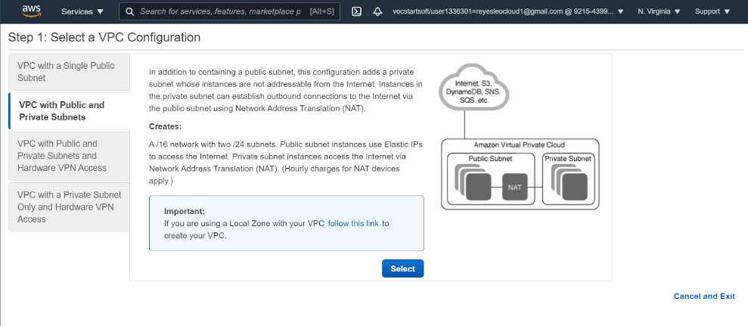

In the VPC wizard, you can select the different things you can set up in the VPC. The image above shows the VPC option selected.

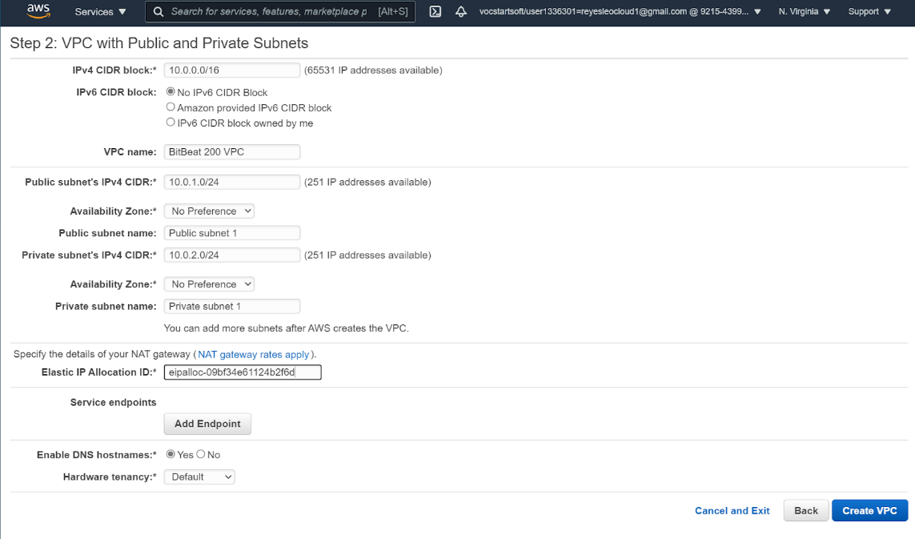

Setting up subnets in the VPC wizard is the same as when it is being set up outside of the wizard. The name of the subnets, the IPv4 blocks of each subnet and the elastic IP used are all shown here.

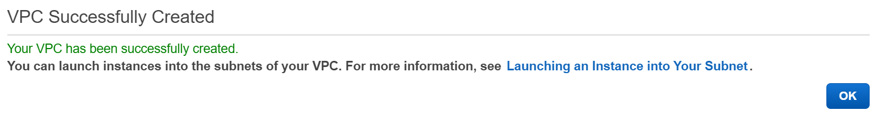

VPC was created successfully when you get this message after waiting a couple of minutes to wait for the resources to be created in the VPC.

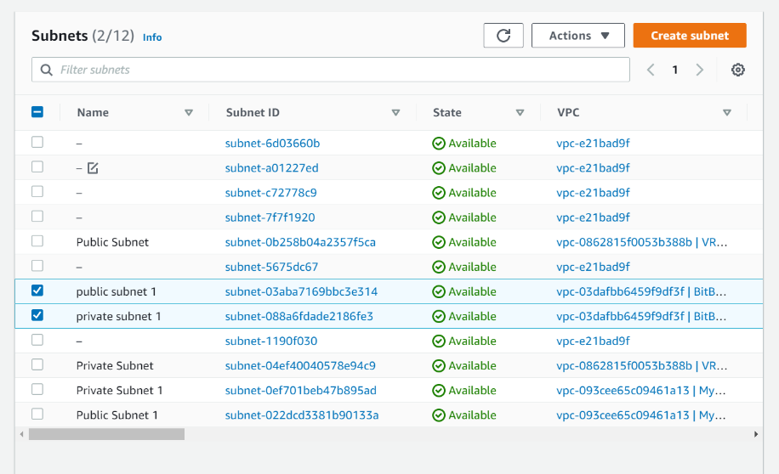

Subnets have been created in the VPC and can be checked in the tab to the left. The name of the VPC is on the columns and you can check what VPC they belong to there.

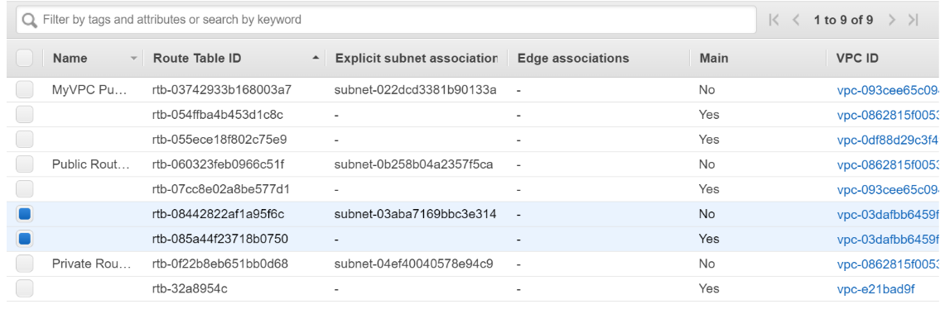

Route tables have been created and can be seen from the tab on the left as well. You can tell each of the tables apart from each other from their VPC ID.

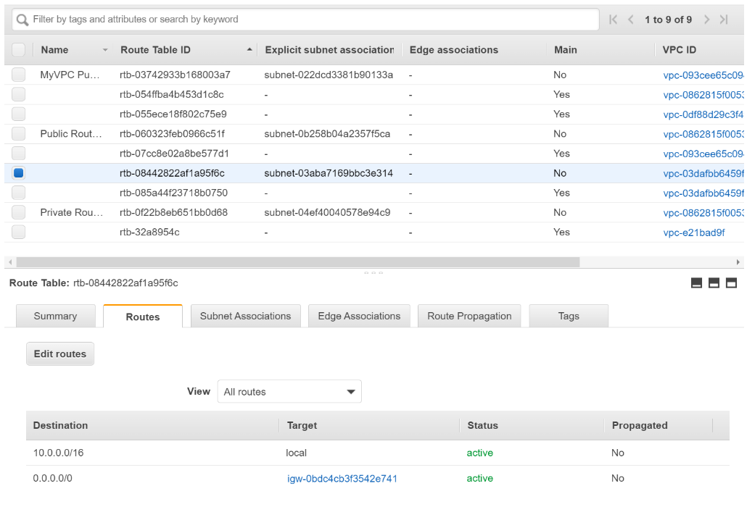

The route tables are created and can be seen on the bottom part of the menu when clicking on one of the tables. The tables then show the routes and their destinations and their target Internet Gateways (IGW).

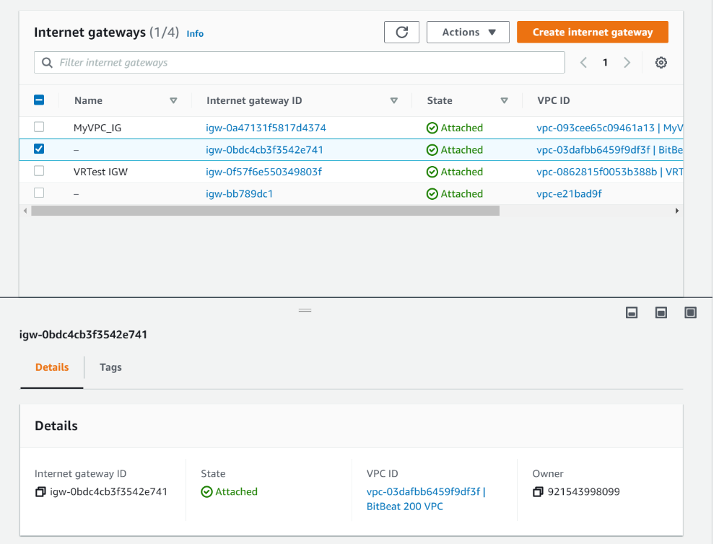

The internet gateways (IGW) can be seen from the tab on the left as well as the subnets and the route tables. This can also be told apart from the others by the VPC ID they are associated with. You can also see it is working from the status of the IGW.

**Problems**

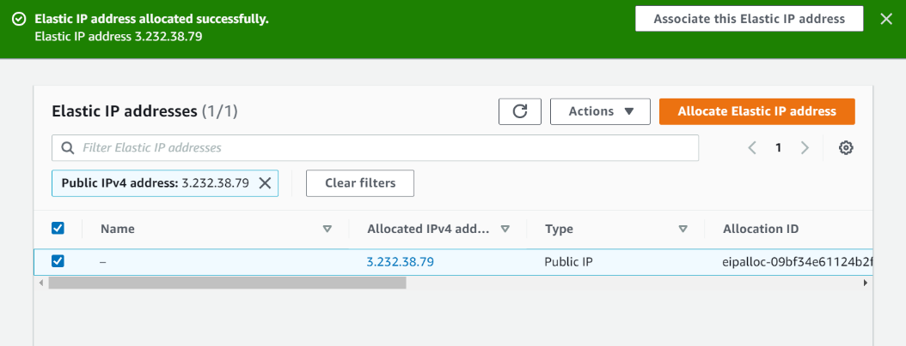

There weren’t that many problems when creating the VPCs with an EC2 service from Amazon. When creating the VPC in the wizard, it will not let you create the VPC unless you allocate an elastic IP address beforehand. To do this, you can go the left menu and after finding Elastic IPs under the Virtual Private Cloud, and click on Allocate Elastic IP address. After this, the wizard allowed me to continue through my process in creating a VPC by assigning the elastic IP with the VPC. After creating the Elastic IP address, the VPC was able to be created successfully.